MAT3300

Assignment 4(119010384)

1. solution:

(a)

Code: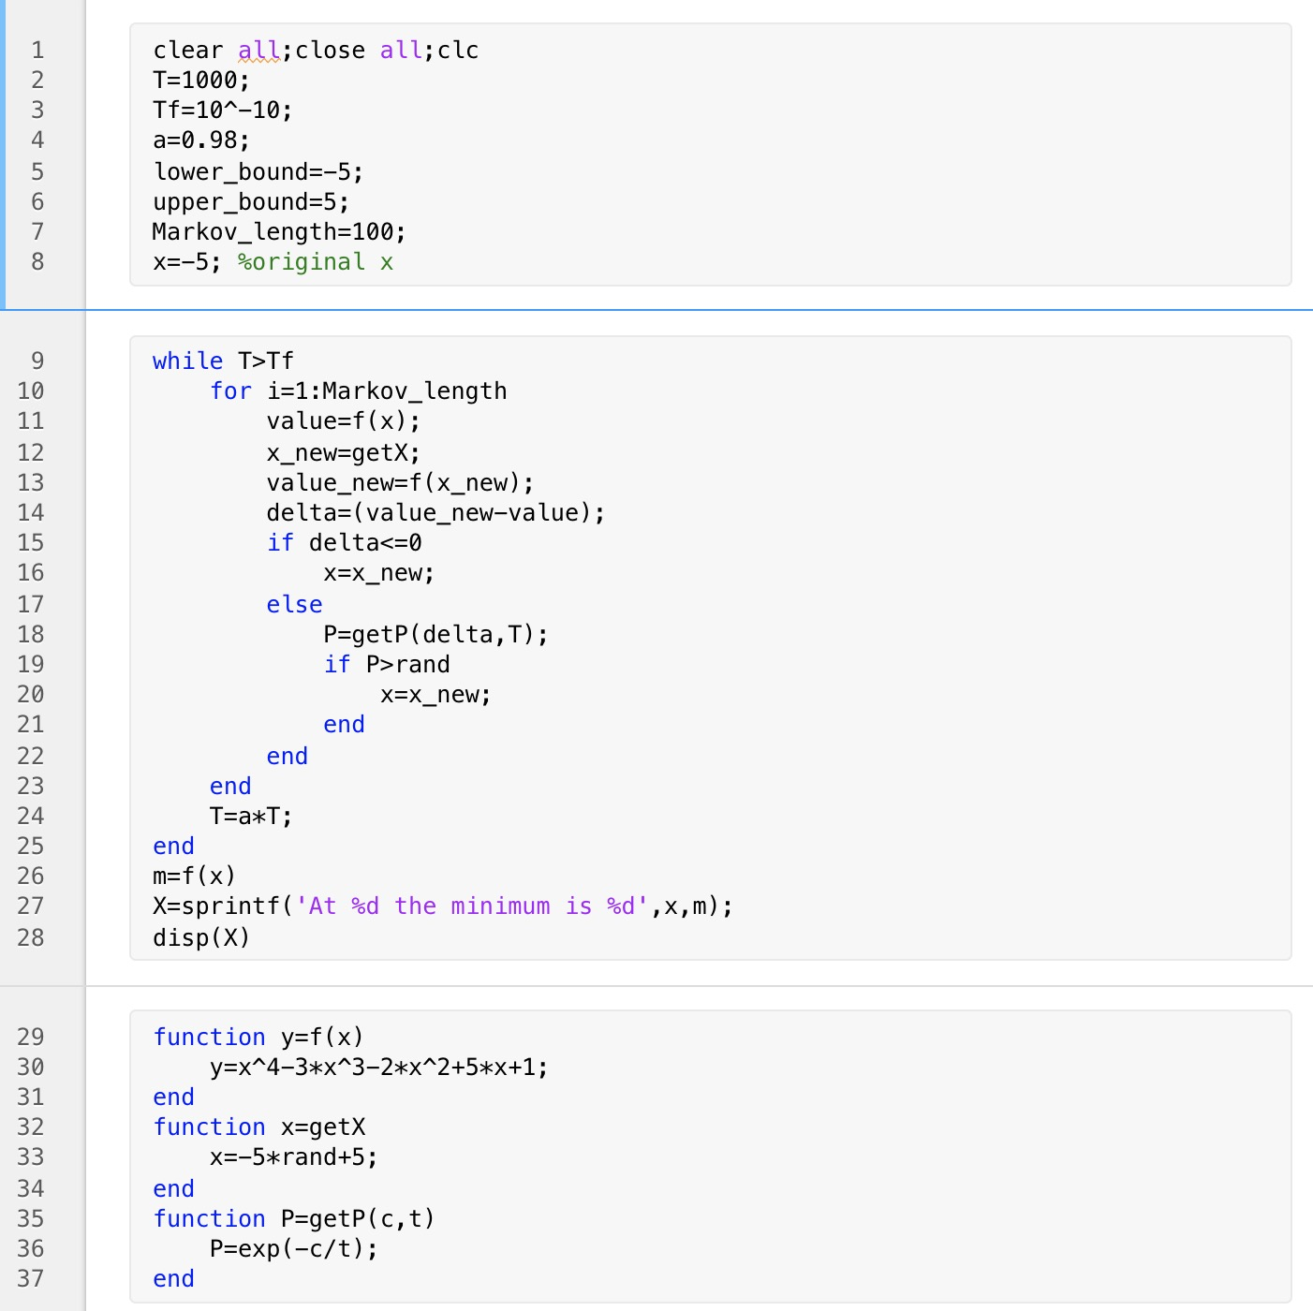

Outcomes:

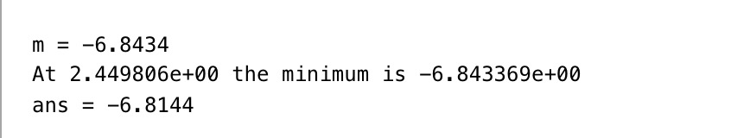

(b)

Code:

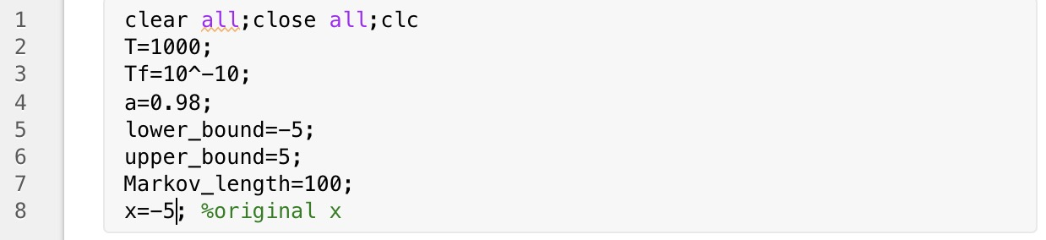

As the code shows, we change the origin x to -5, and the outcomes remain the same.

Hence, the iteration can find the global minimum.

1. solution:

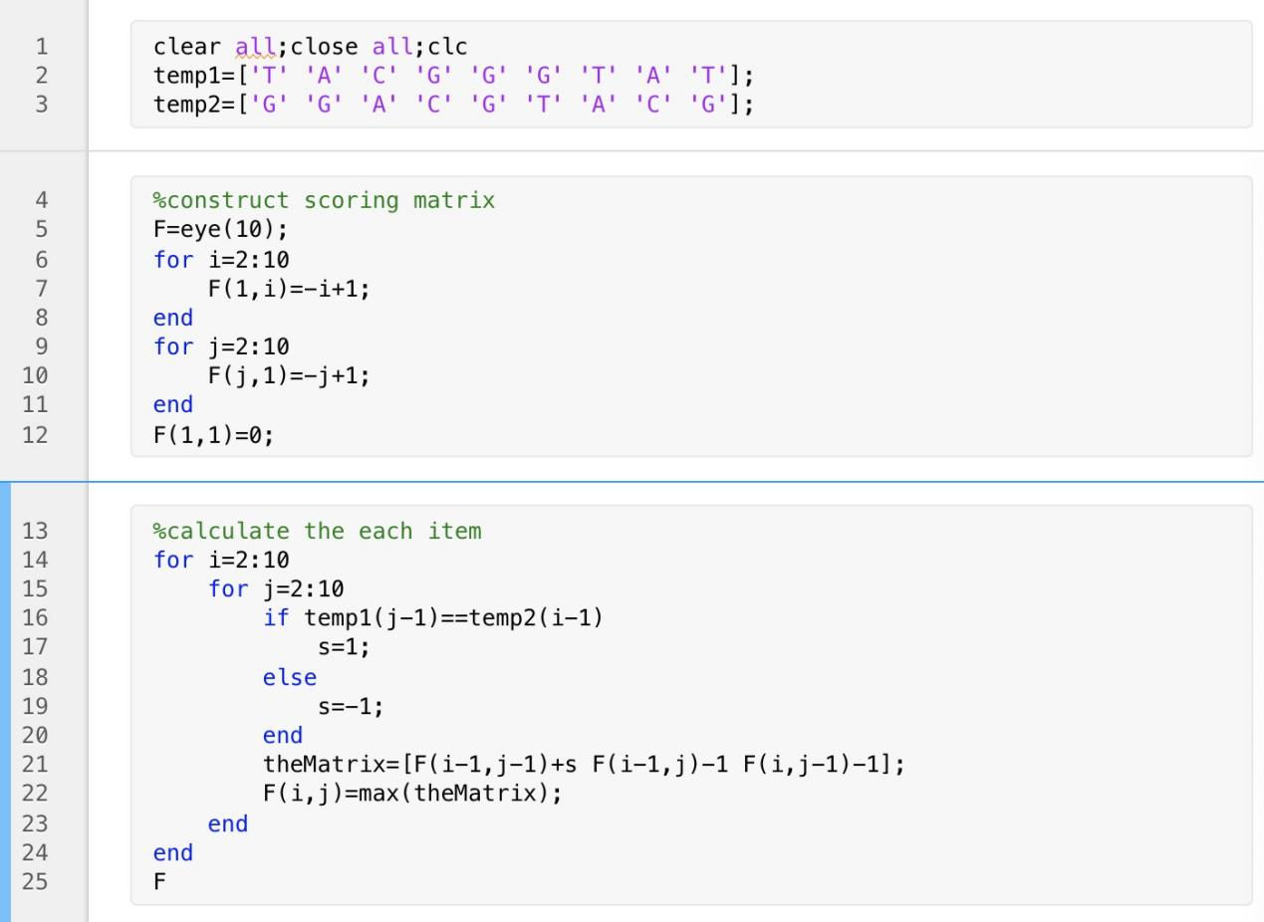

Optimal score=-1

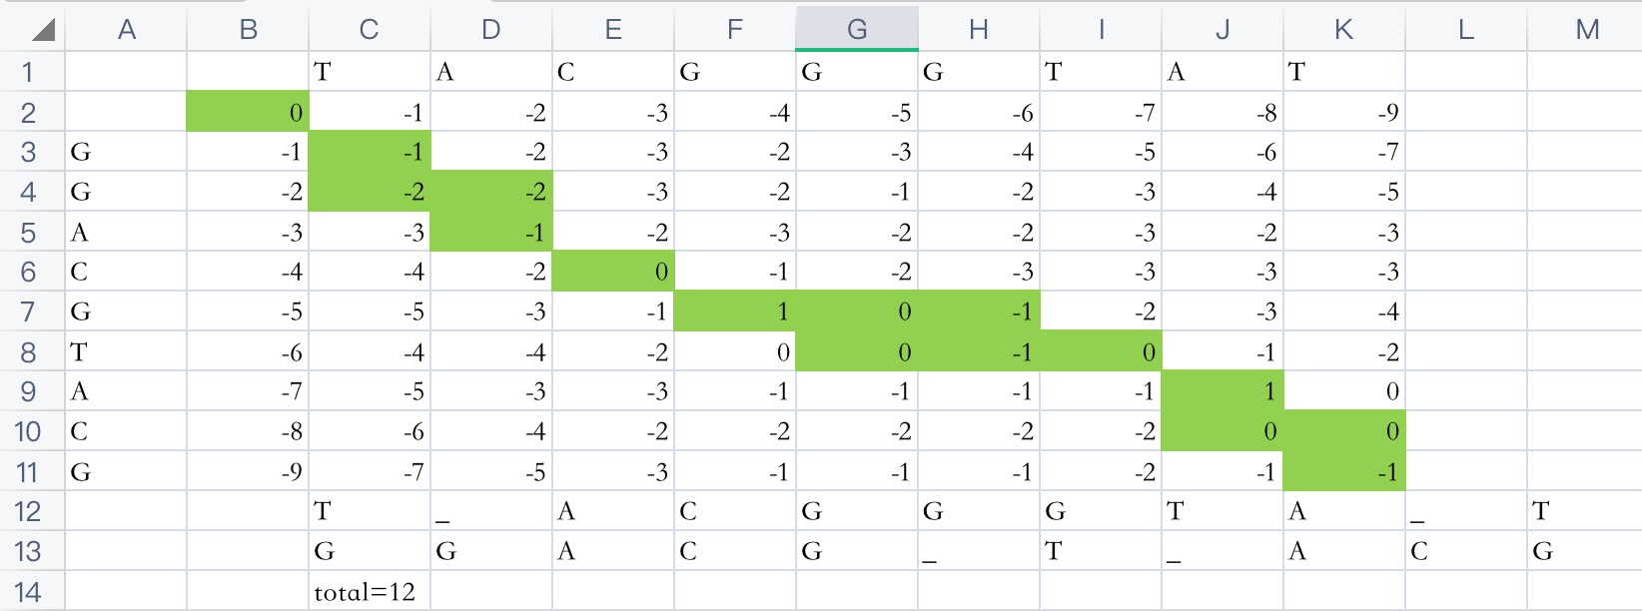

There are 12 alignments.

One of the optimal alignments:

T_ACGGGTA_T

GGACG_T_ACG